Physics lab 6

1 Theory
A simple pendulum is an idealized and simplified model of a real oscillating pendulum. This is a weight (or bob) on the end of a massless rope suspended from a pivot, without friction. Since in this model there is no frictional energy loss, when given an initial displacement it will swing back and forth at a constant amplitude (the friction force and the corresponding damping could be also included in our model, as we will see from the experiment).
The most basic model of a simple pendulum, shown at Fig. 1, is based on these assumptions:
Figure 1: (Color online) A simple pendulum.
The bob is a point mass. Motion occurs only in two dimensions along a flat arc. The gravitational field is uniform and does not change with time. The rope on which the bob is suspended has no mass, as we already mentioned above.
The di↵erential equation which represents the motion of a simple pendulum is derived based on the 2nd Newtons law:
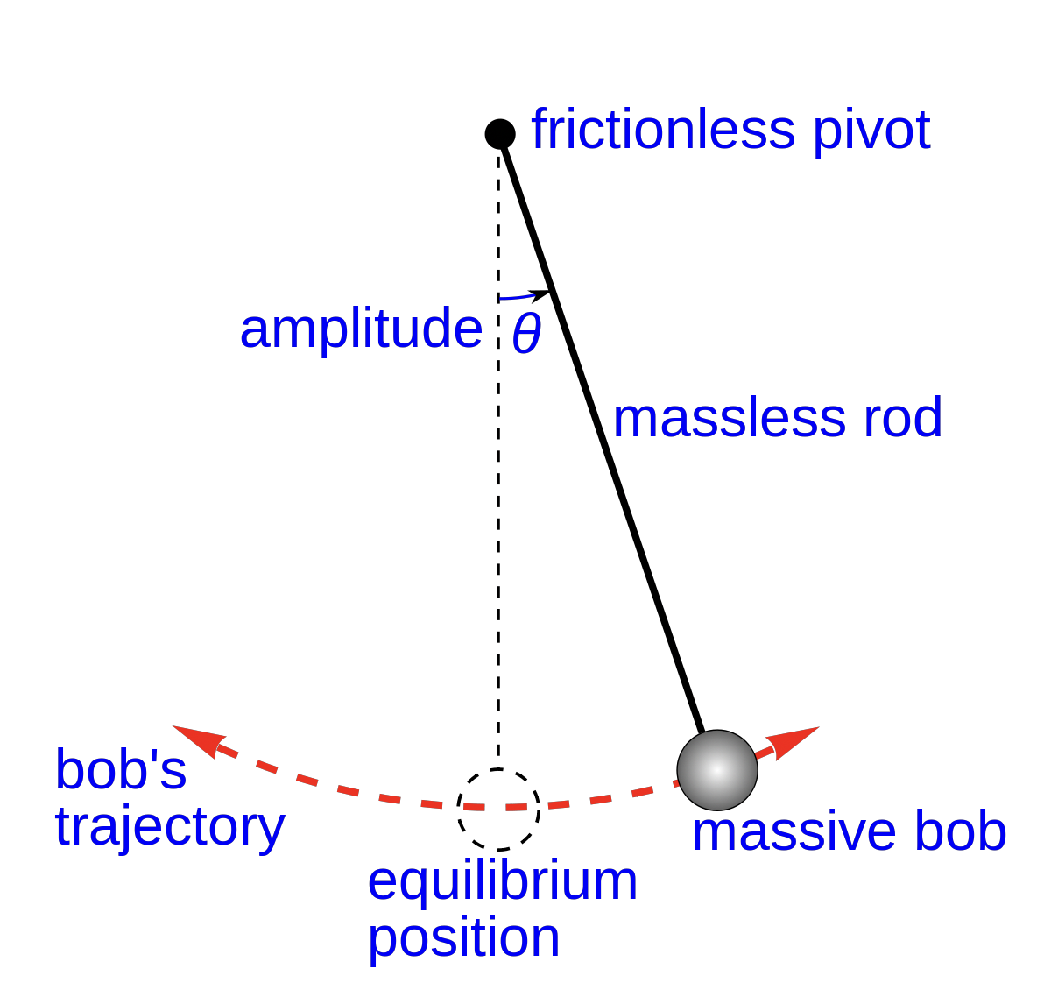
F = ma (1)
and
F = mgL sin ⇥ , (2) where g is the free fall acceleration, mg is the gravity force, L is the length of the pendulum, and
⇥ is its angular displacement from the vertical line.
Figure 2: (Color online) Forces acting on a pendulum.
In a particular case of the pendulum which is released initially at rest ⇣d⇥ = 0⌘ at angle ⇥0 dt t=0
from the vertical position, the solution to the equation of motion of the pendulum becomes ⇥(t) = ⇥0 cos(⌦t) , (3)
where ⌦0 == g/L is the cyclic frequency of this oscillation, while its period (a time for one complete oscillation) is
T = 2⇡ = 2⇡sL . (4) !g
We conclude that the period of a simple pendulum oscillation depends only on the length of its rope and the gravity, but not on the mass of the bob or the amplitude.
The actual frequency
f = 1 = 1 rg , (5) T 2⇡ L
The velocity of a simple harmonic oscillator, including a simple pendulum, is the largest for zero displacement from the equilibrium position, while its acceleration is proportional to displacement and, therefore, disappears for ⇥ = 0.
2 Useful resources
2.1 Educational websites
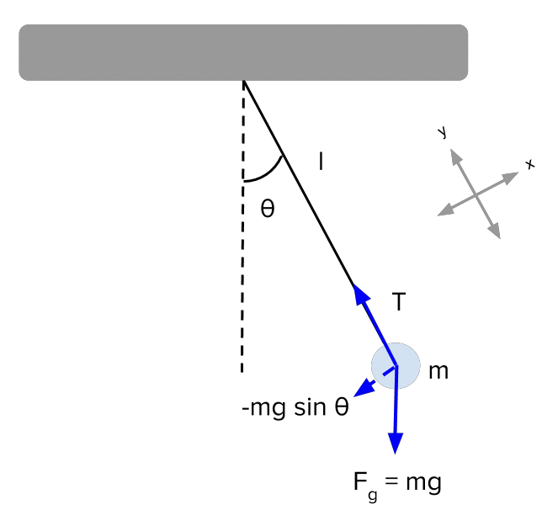
https://courses.lumenlearning.com/physics/chapter/16-4-the-simple-pendulum/

2.2
http://hyperphysics.phy-astr.gsu.edu/hbase/pend.html https://en.wikipedia.org/wiki/Pendulum_(mathematics)
YouTube videos
https://www.youtube.com/watch?v=32204hIO5-Y https://www.youtube.com/watch?v=z6ZdhP167RY https://www.youtube.com/watch?v=LbQuKZD3svI
and many-many others available online.
3 Procedure
1. Go to the website: https://phet.colorado.edu/sims/html/pendulum-lab/latest/pendulum-lab_ en.html
2. Choose the right icon “Lab” and double-click on it.
Part 1. Velocity and acceleration.
- Enable the appearance of the velocity and acceleration by clicking on the corresponding buttons and at the top left of your screen. For all parts of the present experiment, choose zero friction by moving Friction pointer on the right to its leftmost None position 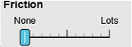. Should you have any finite friction or damping, such oscillator can no longer be considered a simple pendulum, and its frequency would immediately become strongly a↵ected.
- Drag the pendulum to initial angle around 40 0 and release it, a marker of the angular displacement appears and snaps to a nearest degree. Now your screen should look as follows:
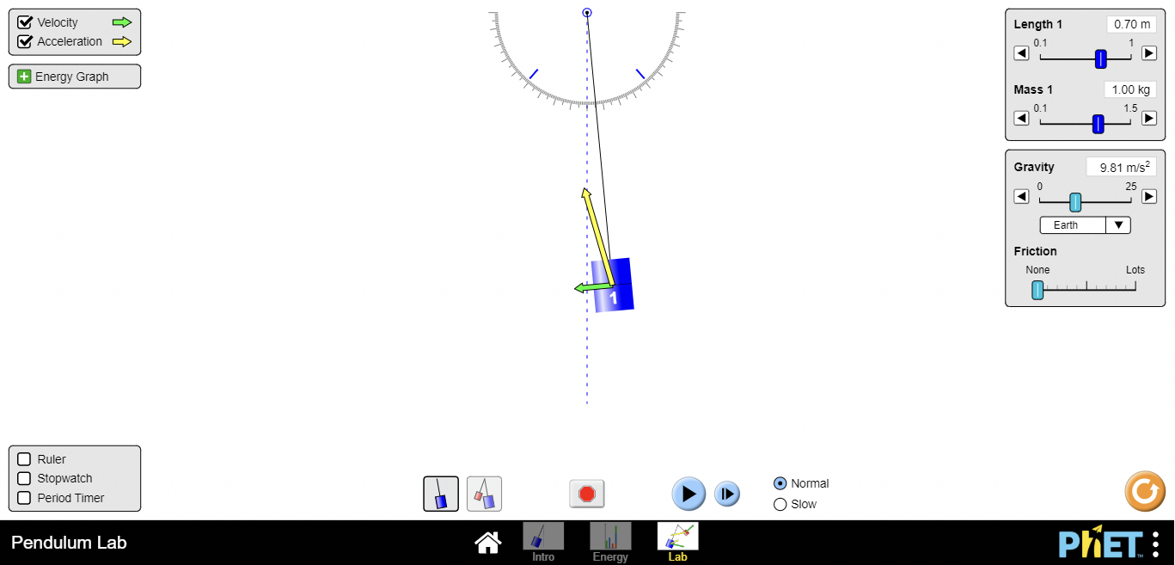
Figure 3: (Color online) Velocity and acceleration of an oscillating simple pendulum.
- Let the pendulum oscillate for a few complete periods and describe how its velocity and acceleration shown by the green and yellow arrows, correspondingly, change throughout the oscillation. When do the observed quantities demonstrate the largest and the smallest magnitudes. Also, please discuss the direction for each of them. You can pause the sim to set up the experiment or watch the video in a slow motion mode.
- Based on the observation from the previous Step, please explain what forces act on the oscillating pendulum and how they depend on the bob’s position.
- Discuss how the the potential and kinetic energies change with time throughout each oscillation. Can you verify if the total energy is conserved? You can click on the Energy Graph icon on the left side of the screen and see the potential and kinetic diagrams to verify your theoretical predictions. The goal of the remaining parts of this lab is to set an experiment to test how various factors a↵ect the period of our pendulum. We begin our tests with the initial angle, or the amplitude of the oscillation. Part 2. Period vs. the amplitude - T vs. ⇥0.
- You can interact with the pendulum and change his mass, length, as well as gravity. Let us begin by choosing length L = (0.7 + 0.01N)m, mass m = (0.4 + 0.02N)kg at an interactive window on the right top, where N is your assigned (roster) number from 1 to 30. Take the initial displacement angle to be ⇥0 = 100 and release the pendulum. Enable the Period Timer by clicking on a V -button at the lower left of your screen, Once you do that, a yellow timer with a play/stop button 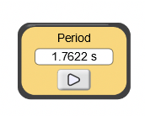will appear on the lower right part of the screen below the oscillating pendulum.
- Observe the oscillations for a few seconds, measure the period of the oscillations for the following values of amplitude (or initial angular displacement of the pendulum): ⇥0 = 10 0, 20 0, 30 0, 40 0, and 50 0. Record your results in Table 1 Table 1. Period of oscillations of a simple pendulum as a function of the amplitude, or initial angular displacement ⇥0 = ⇥(t = 0).
- Is the experimentally measured dependence strong or small? How is it related to the amplitude? In your opinion, would the corresponding theoretical result obtain by Eq. (4) (a single value) be a better description of the case with a small or large amplitude? Why?
- For this exercise, as well as for the next three comparison experiments, it is extremely useful and informative to show the simultaneous oscillations of two pendulums with the di↵erent values of the tested parameter, in our case - the amplitude. Choose Two pendulums by clicking on a button at the bottom of your screen which should now now look in the following way
- 
Amplitude, 0 (degrees) | 10 | 20 | 30 | 40 | 50 | 60
Oscillation period, sec
- 
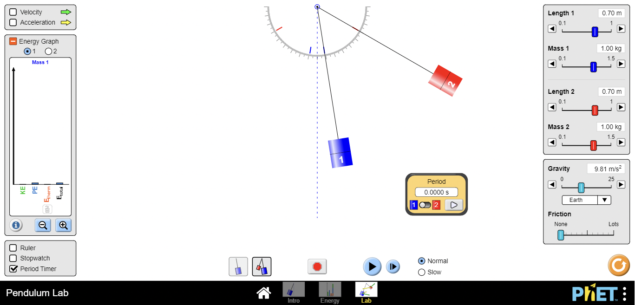
Figure 4: (Color online) Two pendulums used in a comparison experiment.
- Now, we will consider the two identical pendulums with equal masses m1 = m2 = (0.4+0.02 N ) kg and lengths L1 = L2 = (0.7 + 0.01 N ) m. The only parameter which di↵ers for two of them would be the amplitude - the smallest value 100 and the largest one 600. Set the two initial locations as we just described while keeping the simulation on pause.
- Release the two pendulums and compare the periods of their oscillations by observing which of the two pendulums would complete an oscillation in a shorter period of time. Can you verify the previously obtained dependence of the pendulum period on the initial angular displacement? Part 3. Period vs. the mass of the pendulum T vs. m.
- Choose the length of your pendulum to be L = (0.7 + 0.01 N ) m and the amplitude ⇥0 = (10 + 2.0 N ) 0, where N is your assigned (roster) number from 1 to 30. Enable the Period Timer by clicking on a V -button at the lower left of your screen.
- Measure the period of the oscillations of your pendulum for the following values its mass: m = 0.1 kg, 0.4 kg, 0.7 kg, 1.0 kg, 1.2 kg and 1.4 kg. Record your results in Table 2 Table 2. Period of oscillations of a simple pendulum as a function of its mass m.
- Is the experimentally obtained dependence on the mass strong or small, or you did not find any dependence at all? In your opinion, would the corresponding theoretical result obtain by Eq. (4) (a single value) be a better description of the case with a small or large mass? Why?
Mass, kg (degrees) | 0.1 | 0.4 | 0.7 | 1.0 | 1.2 | 1.5
Oscillation period, sec
Part 4. Period vs. the the length of the pendulum - T vs. L.
- Select the mass of your pendulum to be m = (0.7 + 0.01 N ) m and the amplitude ⇥0 = (10 + 2.0 N ) 0, where N is your assigned (roster) number from 1 to 30. Enable the Period Timer by clicking on a V -button at the lower left of your screen.
- Measure the period of the oscillations of your pendulum for the following values its length: L = 0.1 kg, 0.2 kg, 0.3 kg, 0.5 kg, 0.8 kg and 1.0 kg. Record your results in Table 3 Table 3. Period of oscillations of a simple pendulum as a function of its mass m. Part 5. Determining the gravitational acceleration g.
- Using the experimentally obtained results from Table 3, plot your L vs. T 2 (squared !!!) data for each pendulum length Le,1, Le,2, ... Le,6 and the corresponding squared os- cillation period T 2 , T 2 , ... T 2 . Using Microsoft Excel, Google Spreadsheet or e,1 e,2 e,6 https://www.geogebra.org/, find the slope of the best fit straight line. Calculate the average gravity acceleration from (according to Eq. (4))
Length, m | 0.1 | 0.2 | 0.3 | 0.5 | 0.8 | 1.0
Oscillation period, sec
or
Slope = gexp (6) 4⇡2
gexp = 4⇡2 · Slope , (7)
and compare it to the theoretically accepted value of the free fall acceleration gacc = 9.81m/s2. Calculate the percent error for your experimental result gexp using the following expression
%error=2|gexp gacc| ·100%. (8) gexp + gacc
- Choose the value of the Gravity, or the free fall acceleration due to the gravity, which corresponds to Jupiter, by selecting this planet on the right of your screen .
- Repeat Steps 17-20 and obtain the experimental value for the gravitational acceleration on the surface of Jupiter and compare it with the theoretically accepted value g(J) = 24.79m/s2. Calculate the percent error for your experimental result g(J) using the exp
following expression
(J) (J) %error=2 gexp gacc ·100%.
(9)

